Omshree R Hiremath

Emp Code: 655127

Day – 8

Azure Datafactory

Exercise – 1  
Wait Activity

Add Parameters to pipeline

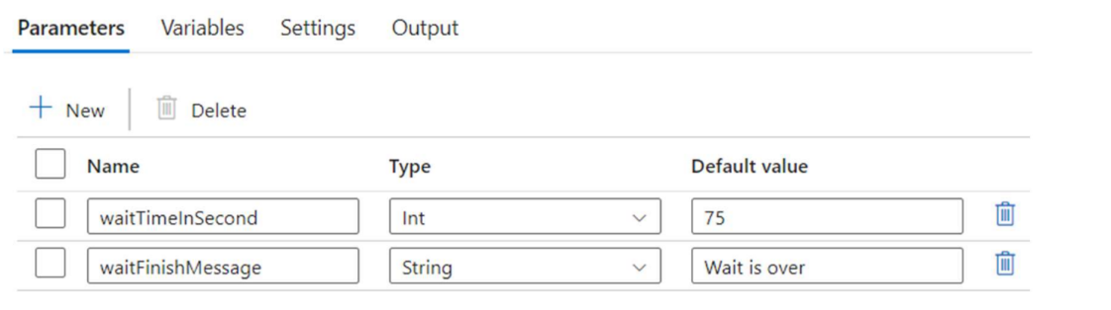

Drag and Drop Wait Activity

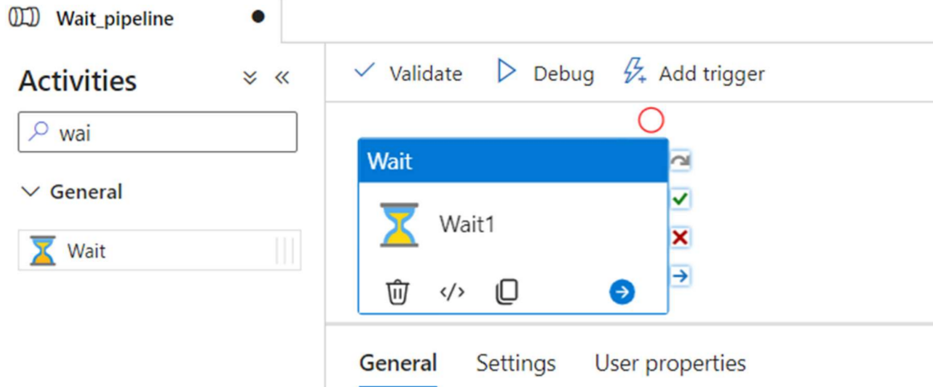

Validate the Pipeline and Run it

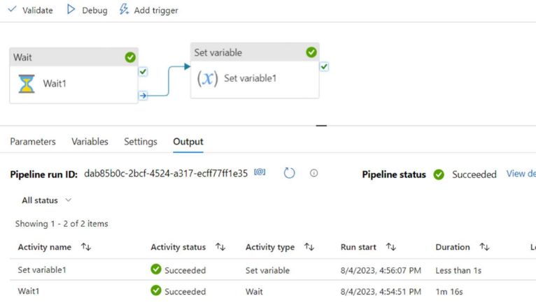

Exercise – 2

Mapping Data Flow

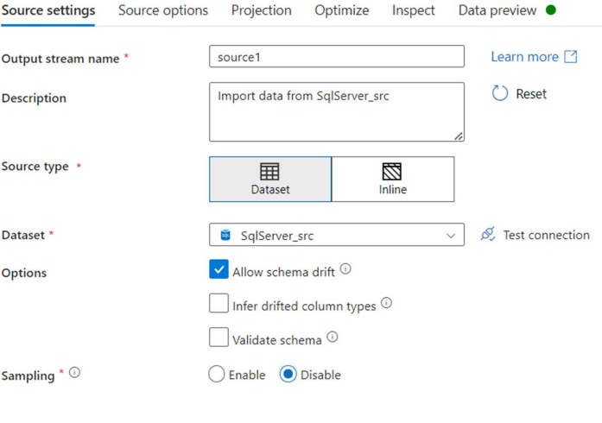

Create and add dataset to Sink

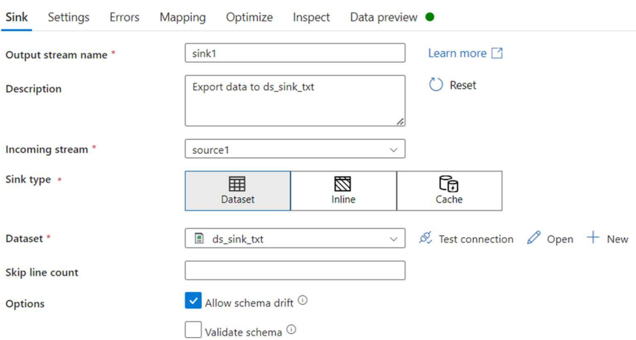

**Drag and drop the Data Flow and update the settings**

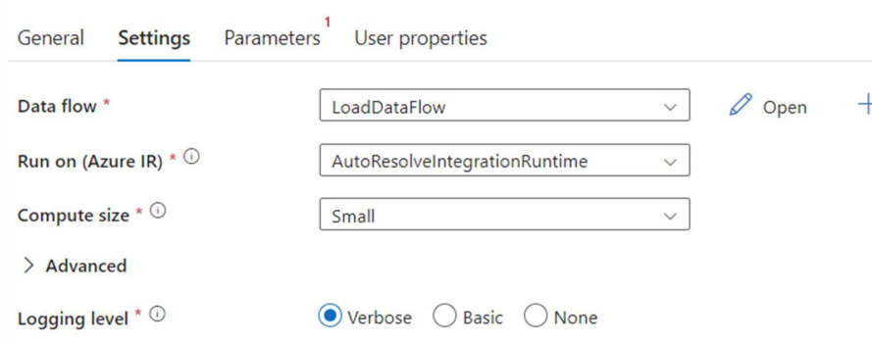

**Pipeline validated and executed**

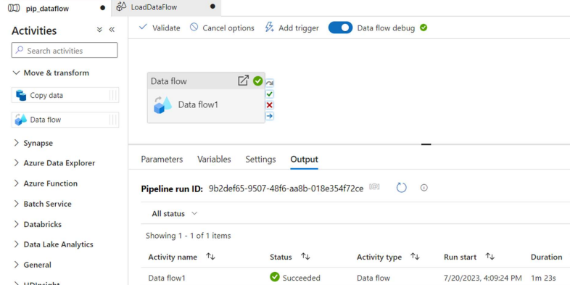

**Output**

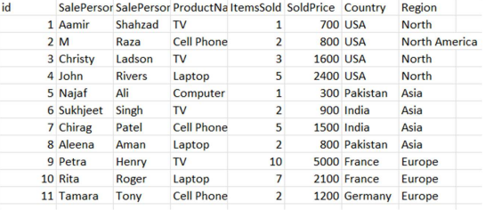

**Select Transformation:**

**Upload the Employee.csv file provided**

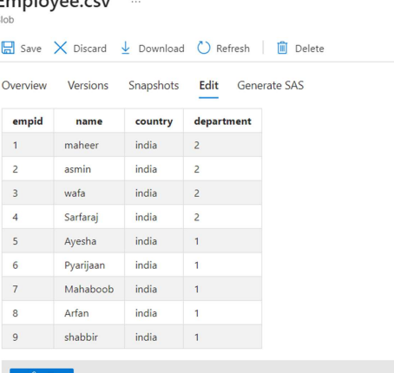

**Select Data Source and add the source selection**

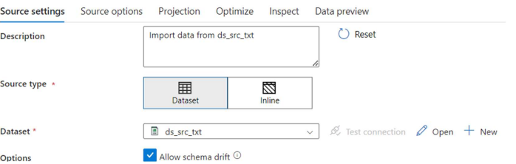

**Change the column names**

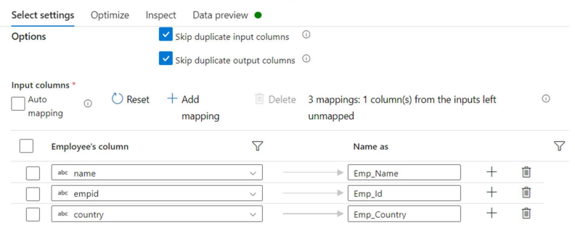

**Set the destination on sink, validate the pipeline and execute**

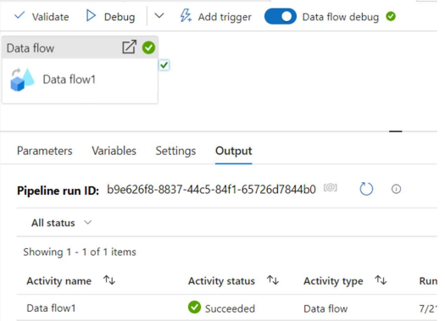

**Check the output**

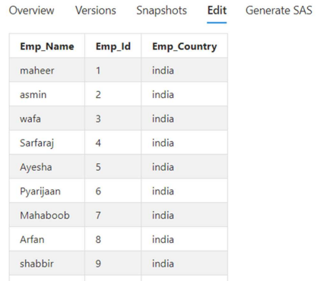

**Conditional Split Transformation**

**Select the Employee table as source**

**Select Conditional Split and change the default conditions**

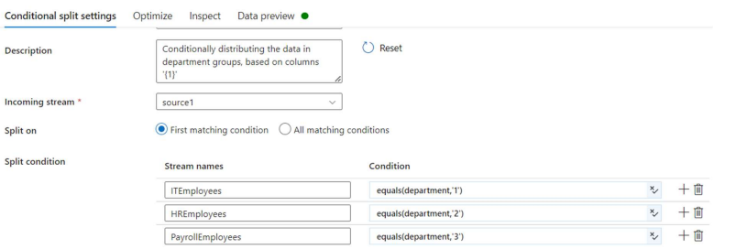

Set the destination in Sink parameter

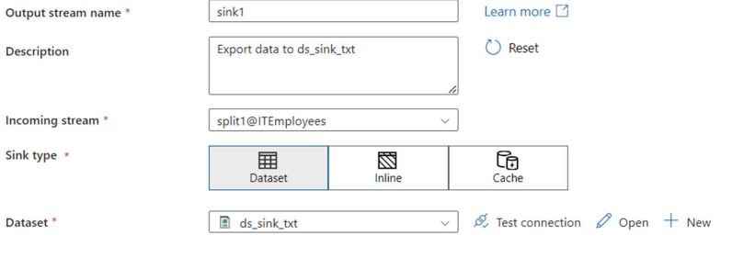

Adding sinks for the other conditions

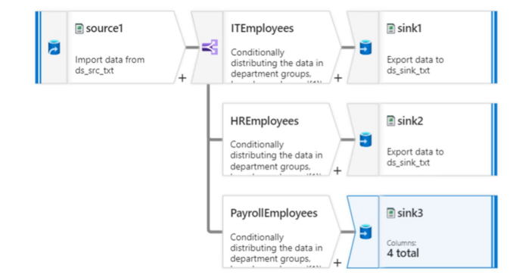

Validate and pipeline executed successfully

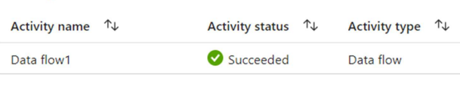

Derived Column Transformation

Set Employee dataset as the source

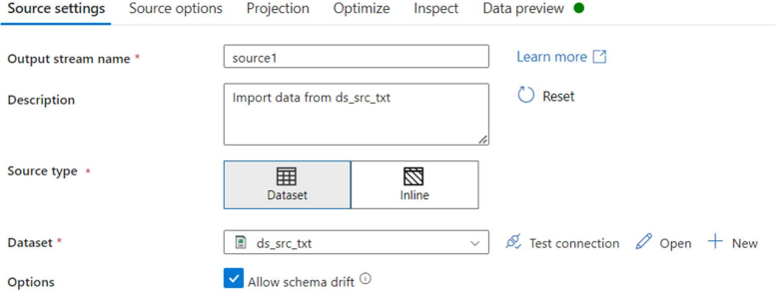

Adding Expressions

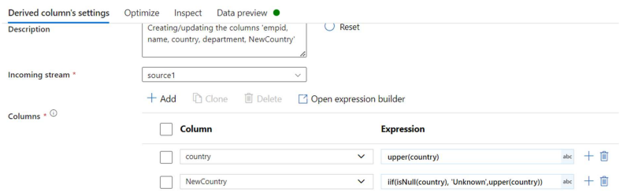

Set the sink

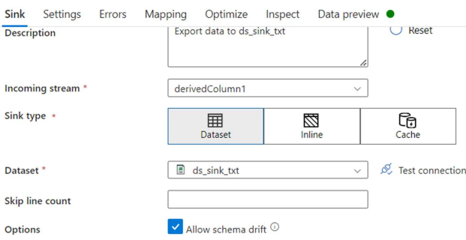

Validate the pipeline and after successful execution, check the output

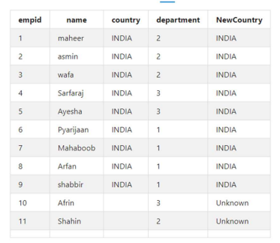

Union Transformation  
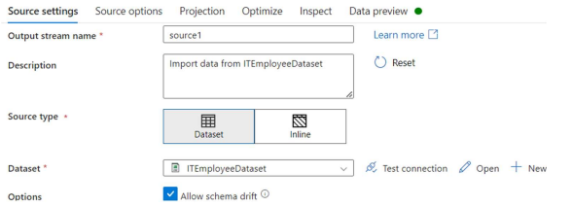

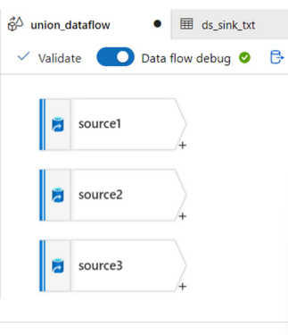

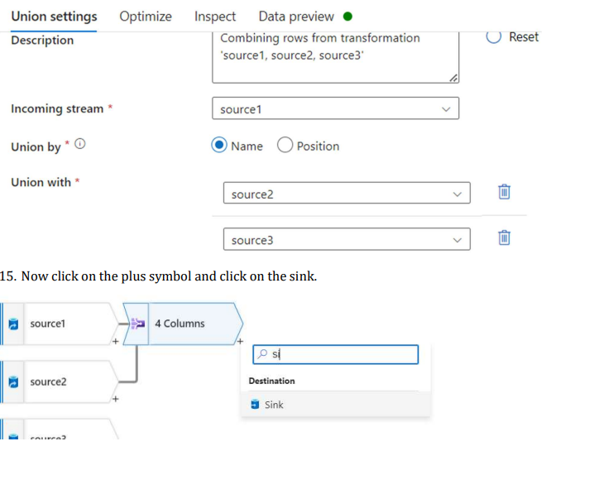

Sink-destination

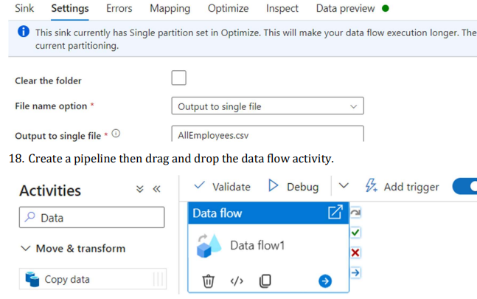

Validate and after successful execution, you see the following

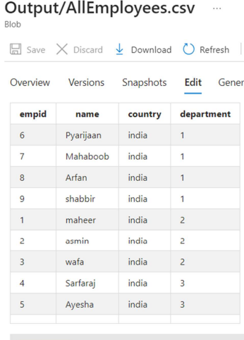

Sort Transformation